DIRTY COW
(CVE-2016-5195)
A Linux kernel Exploit

A Seminar Report

Subhmitted by

SUBHAJIT BARH
(18MA60R33)

in the partial fulfilment for the award of the degree
of

MASTER OF TECHNOLOGY
in
COMPUTER SCIENCE AND DATA PROCESSING
at


DEPERTMENT OF MATHEMATICS
INDIAN INSTITUTE OF TECHNOLOGY KHARAGPUR
WESTBENGAL-721302,INDIA

February 2019

ABSTRACT

Though linux is lagging in the desktop user market(only 2.7 % user uses linux according to a servey of november 2018 ) severs uses Linux extensively arround 80% servers uses linux and populer mobile operating system linke android also uses linux kernel underneath it.
When in a operating system of that magnitude we found a security vulnerability it is really scary for all kind of reasons.Though Linux is over all really a secure operating system than its counterparts it also had its bad days.
2016 november was a nightmare for linux developers because in that month Dirty COW(CVE-2016-5195) was descovered by a security researcher named Phil Oester.It is an Privilage Escalation Vulnerability and it utilizes race condition to exploit an ancient flaw in the linux kernel .Linux Kernel version 2.6.22 (Released in 2007) to kernel 4.8.3 (in 2017) are vulnerable.Now Linus Torvalds the father of the Linux project said that he discovered it a long time ego tried to fix in vain he termed it as theoritical vulnerability.But it is not theoritycal any more .
Linux tried to fix the BUG in 2016 but was not success but the patch was not full proof .In 2017 it was fully patched and it is Dirty COW free from linux kernel 4.15(UBUNTU 18.04).
So staying updated is the only defence we have in this scenario.So in this seminar report i will try to explain what was the bug and how it was exploited.

What is Dirty COW

Dirty COW is a privilage escation type vulnerability .It is ientified as CVE-2016-5195 .
It got CVE score of 7.2 which is pretty high . Any server running linux kernel 2.6.22-4.8.* is vulnerable to this attack .It was Discovered by Phil Oester in 2016 and it exsisted almost 10 years before fully patched.

What is Privilage Escalation

Privilage Escalation or priv-esc is an attack(technique) through which an normal user can elevate or escalate his privilage .Earning root privilage can be a tidious job when it comes to security research.
But with Dirty COW it becomes easy and any script-kiddy can do it.

What is Race Condition:
Dirty COW is a race condition vulnerability. When Two process or two indepenent thread are running on the same resources it is impossible to say which job will occur first and which will occur second .so it is poorly sequenced.it is called race condition because two jobs are running for the same resource at the same time .Dirty COW leverages that situation .

Permission Systems in Linux:
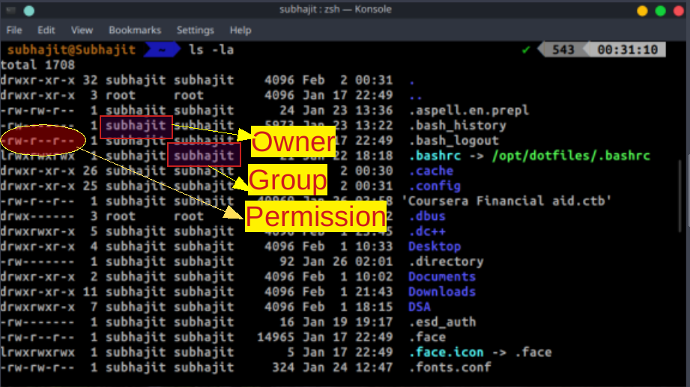
as shown in the figure 10 charecters are used for permission in linux
first characher :‘-’ if its file and d if it is directory
Next 3 letters are permission for owner
- ‘r’ means read privilage
- ‘w’ means write privilage
- ‘x’ means execution privilage
Next 3 letters are for groups(same description)
Next 3 are for others
‘-’ means absent of permission
If ‘-’ is there in place of w that means it is write protected
‘root’ - is the Highest privilage in linux

Root has all the permissions that is read write and execute .
We want to become root from normal users ....
Some times it is needed to run root commands despite being non root.for this there is a command called sudo (Superuser Do) whitch grants you temporary root privilage if you(user) are listeted in sudoers(/etc/sudoers) file
What if you are not in sudoers file ?? can you gain root privilage ??Normally you can’t.But you can take advantage of security loop-holes and escalate your privilage.That is called privilage escatation attack.There are many Priv-Esc methedologies .One of them is exploiting Kernel .It is Dengerous and unstable .But can grant you root privilage.Dirty Cow is an Kernel Exploit.

